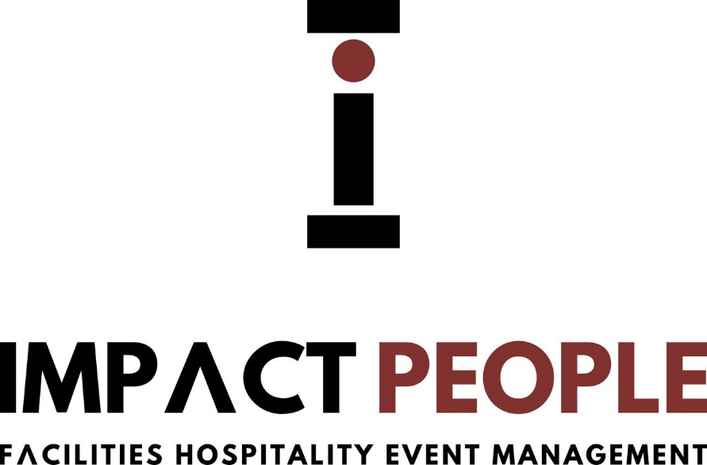

Environmental Policy

Impact People Management LTD is a supplier of temporary staff business with core values that promotes positive action against climate change through business partnerships.

- Impact People Management LTD acknowledges that it has a responsibility to minimise the use of materials in the workplace and educate staff to be more responsible towards energy consumption.
- Impact People Management LTD is committed to utilising recycled materials encouraging business partners to do likewise.
- Impact People Management LTD is striving towards a paperless office and is dedicated to electronic means of communication where legally permissible.
- All lighting and non-essential electrical equipment will be switched off when not used and at night and on the weekends.
- The recycling of waste is constantly adhered to.
- All paper-based products will be recycled.
- Printer cartridges will be returned to the manufacturer for re-use.
- Office glass, plastic and tins will be collected and disposed of in the appropriate containers provided by the local authority.
- Car sharing for staff members is promoted along with encouraging staff to walk or cycle to and from work.
- Impact People Management LTD advocates that its clients take climate control seriously and maintain a sense of responsibility and best practice with environmental issues.

